Title in Title Case (Times New Roman bold 12 font)
by Name Autor¹ and Name Autor² (FirstName Surname Italics 11 font)²
¹ Affiliation for author (10 font)
² Affiliation for author (10 font)
Keywords: Suggested maximum of 5 to 6 keywords (10 font)
Use concise and clear English to write your abstract.
Abstracts are to be written in Times New Roman, 11pt font, single line spacing and justified, with margins of 25 mm on each side, and 15 mm each at the top and bottom.
Abstracts have a maximum limit of 2 pages. Optional you can include 1 figure or 1 table. If using figure or table refer to it in the text as (Figure 1) or (Table 1).
Use one hard return for a new paragraph (between paragraphs use spacing 6 pt after) and do not use indents. This includes the title and affiliations, all text (any images) and references.
Spell out all acronyms in full in the first instance, with the acronym in parentheses. After this, the acronym can be used.
References within the text should be referred to "as demonstrated (Allan, 2020a, 2020b; Allan and Jones, 2019)" or "as demonstrated (Jones, 2019; Allan, 2020). Kramer et al. (2023) have recently shown". References should be listed in full and at the end of the abstract. The references should be arranged alphabetically and then chronologically if necessary. More than one reference from the same author(s) in the same year must be identified by the letters 'a', 'b', 'c', etc., placed after the year of publication See reference style in the example below (page 3).
Please save your file giving the session number (S#) and then first author’s surname in the following format: “S#_Smith-IAGOD2026poster.docx” or “S#_Smith-IAGOD2026oral.docx” (depending on your preference of presentation) and email it to: iagod.symposium2026@gmail.com. We kindly request that you submit the abstract information in the submission information form. If not possible, please indicate in your email message the preferred session and preferred presentation type: ‘poster’, ‘oral’ or ‘no preference’ when submitting your abstract.

Acknowledgments are optional. If included, they should appear at the end of the text.

Abstracts not in the correct format will be returned to authors, who will be asked to resubmit, if time permits.

The editors reserve the right to edit your abstract if it exceeds this limit.

Please follow these Abstract guidelines. “Abstract Example” on pages 2 and 3 provides more clarification and follows the formatting explained above.

Abstract Example: file name “S#_Dolgopolova-IAGOD2026oral-abstract.doc”
Sr-Nd-Pb-Hf Isotope Systematics of the Hugo Dummett Cu-Au Porphyry Deposit
by Alla Dolgopolova¹, Reimar Seltmann¹ and Elena Belousov²
¹ Natural History Museum, CERCAMS, Cromwell Road, London, UK
² Geological Survey of Queensland (GSQ), Brisbane, Australia

Keywords: Hugo Dummett, Oyu Tolgoi, Mongolia, juvenile, Sr-Nd-Hf-Pb isotopes
Summary
Major and trace element geochemistry including Sr-Nd-Pb-Hf isotopic data are presented for a representative sample suite of Late Devonian to Early Carboniferous plutonic and volcanic rocks from the Hugo Dummett deposit of the Oyu Tolgoi porphyry Cu-Au district in the South Gobi, Mongolia. All four isotopic systems suggest that the magmas from which the Oyu Tolgoi porphyry system was generated originated predominantly from juvenile material within subduction-related setting of Gurvansaihan terrane.
Introduction
The Hugo Dummett copper-gold deposit is a part of the giant Oyu Tolgoi porphyry district in South Gobi of Mongolia. The district is situated within the Central Asian Orogenic Belt (CAOB), one of the largest orogens on Earth (Khain et al., 2003; Kröner et al., 2007). The CAOB (or the Altaid Tectonic Collage, Şengör et al., 1993) is a prime example of accretionary orogeny and represents a complex pattern of Neoproterozoic to Mesozoic orogenic belts. The Oyu Tolgoi group of deposits represent a typical porphyry system formed in an island-arc setting (Khashgerel et al., 2006). Whole-rock Sr, Nd, Pb and zircon Hf isotopic compositions are presented for Late Devonian to Early Carboniferous intrusions and their volcanic host rocks to infer their geotectonic setting, evaluate mechanisms of crustal generation, deﬁne the composition of mantle sources, and to estimate the role of juvenile crust at Oyu Tolgoi and nearby areas.
Geological Setting
The Oyu Tolgoi deposits are situated 650 km south of the Mongolian capital Ulaanbaatar. The Oyu Tolgoi property comprises six main exploration prospects comprising Hugo Dummett (North and South), Central Oyu, South and Southwest Oyu, Heruga North and Heruga (Kavalieris et al., 2011). This study focuses mainly on the Hugo Dummett deposits that in plan view extend for over 3 km from SW to NE. The geology, alteration and mineralisation are similar at Hugo Dummett North and Hugo Dummett South (Khashgerel, 2006). Both deposits are hosted mainly by quartz monzodiorite.
The high-grade (>2.5% Cu) sulphide mineralization is associated with intense quartz veining and is comprised of bornite, chalcocite and chalcopyrite, with bornite being predominant. Pyrite, enargite and tetrahedrite-tennantite occur in subordinate amounts, mainly in the Hugo Dummett South. Advanced argillic alteration within the tuffs is accompanied by alunite, pyrophyllite, diaspore, dickite, topaz, zunyite and fluorite.
Discussion and conclusions
Effects of alteration
The data fall comfortably within the "mantle array" in the depleted-source values of the ⁸⁷Sr/⁸⁶Srt; this could reflect either variations in the source region, or relatively minor degree of contamination of the most LIL-depleted examples. There is no evidence for massive contamination with crustal radiogenic Sr, for example. Sr and Nd isotope data yield conclusions as to a LIL-depleted source that are fully consistent with the evidence of Hf isotopes in zircon. Even if it were admitted that the Sr, Nd and Pb isotope systems were the product of complete equilibration with hydrothermal solutions, these would necessarily have also originated within the same magmatic system, and the alteration must have occurred very soon after igneous crystallization for all four isotope systems to record and maintain the same signature.
Indications of juvenile magmatism
Sr and Nd isotopes (whole-rock) show restricted ranges of initial compositions, with positive εNdt mainly between +3.4 and +7.4 (Figure 1) and (⁸⁷Sr/⁸⁶Sr)t predominantly between 0.7037 and 0.7045 reflecting magma generation from a relatively uniform juvenile lithophile-element depleted source. Previously dated zircons from the plutonic rocks exhibit a sample-averaged range of εHft values of +11.6 to +14.5 (Figure 1). Depleted-mantle model ages of 420-830 (Nd) and 320-730 Ma (zircon Hf) limit the involvement of pre-Neoproterozoic crust in the petrogenesis of the intermediate to felsic calc-alkaline magmas to, at most, a minor role. Pb isotopes (whole-rock) show a narrow range of unradiogenic initial compositions: ²⁰⁶Pb/²⁰⁴Pb 17.40-17.94, ²⁰⁷Pb/²⁰⁴Pb 15.43-15.49 and ²⁰⁸Pb/²⁰⁴Pb 37.25-37.64, in agreement with Sr-Nd-Hf isotopes indicating the dominance of a mantle component. All four isotopic systems suggest that the magmas from which the large Oyu Tolgoi porphyry system was generated originated predominantly from juvenile material within the subduction-related setting of the Gurvansaihan terrane.
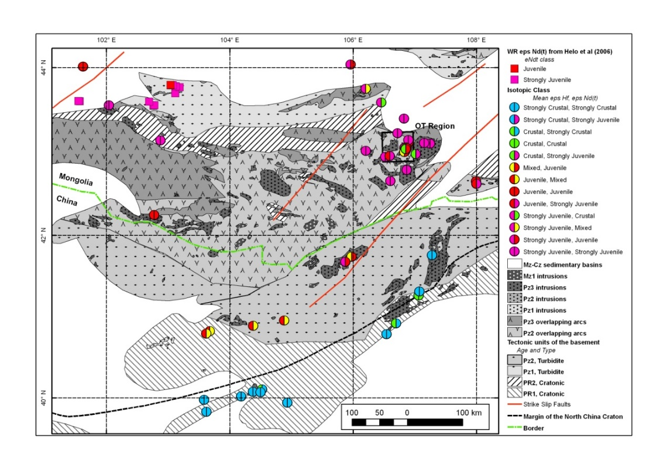
Figure 1. εHf and εNd data plotted for the South Gobi area (compilation of the CERCAMS Altaids project).

Acknowledgments
Ivanhoe Mines Mongolia is thanked for its continuous support and for providing samples for this study. Douglas Kirwin is especially thanked for support and inspiration. The Hf analytical data were obtained using instrumentation funded by DEST Systemic Infrastructure Grants, ARC LIEF, NCRIS, industry partners and Macquarie University. This is a contribution to IGCP-592 sponsored by UNESCO-IUGS.
References
Kavalieris, I., Rinchin, O., Gombojav, J., Gombosuren, N., Crane, D., Orssich, C. & Khashgerel, B.-E. (2011) Characteristics of the Oyu Tolgoi porphyry deposits, South Gobi, Mongolia. Abstract volume, 11th SGA Biennial Meeting, Antofagasta, Chile, September 26-29, 2011, A111.
Khashgerel, B.-E., Rye, R.O., Hedenquist, J.W. & Kavalieris, I. (2006) Geology and reconnaissance stable isotope study of the Oyu Tolgoi porphyry Cu–Au system, South Gobi, Mongolia. Economic Geology 101, 503-522.
Kröner, A., Windley, B.F., Badarch, G., Tomurtogoo, O., Hegner, E., Jahn, B.B., Grushka, S., Khain, E.V., Demoux, A. & Wingate, M.T.D. (2007) Accretionary growth and crust-formation in the Central Asian Orogenic Belt and comparison with the Arabian–Nubian shield. Geological Society of America, Memoirs 200: 181-209.
Şengör, A.M.C., Natal’in, B.A. & Burtman, V.S. (1993) Evolution of the Altaid tectonic collage and Paleozoic crustal growth in Eurasia: Nature 364, 299-307.

